**COS30045**

**Data Visualisation**

Mohamed Usaidh Abdul Razzaq – 105017157 (Group 25)

Project Stand-Up 2

**1. Progress Since Last Standup:**

* **Data Collection**: Datasets have been acquired from the OECD related to chronic diseases, including diabetes, asthma and other chronic diseases, and risk factors such as smoking and such from 2000 to 2020.

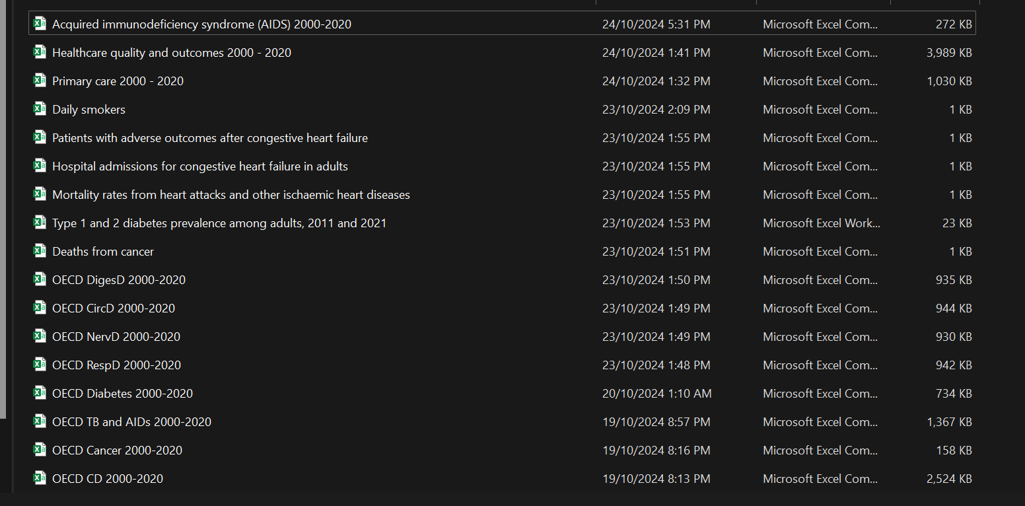

* **Data Cleaning and Processing**: Have started cleaning the data, removing inconsistencies, and organizing it for visualizations. This includes ensuring that the data is normalized and categorized by factors such as year, country, and disease incidence

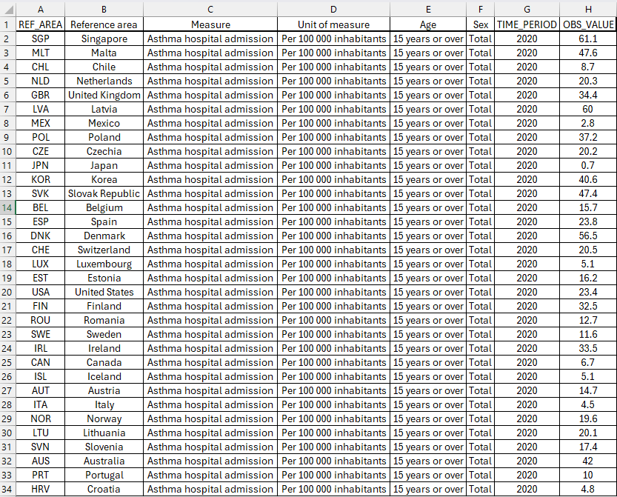

* **Designing the Visualization**: Currently drafting the map visualization. Basic idea has been sketched and structured, and GeoJson file uploaded to GitHub.

* **Process Book**: The initial sections of the Process Book are ready, covering data collection and the design process.

* **Contribution Estimate**:
  + **Data work**: ~20 hours (50%)
  + **Visualization Design**: ~10 hours (25%)
  + **Process Book Writing**: ~6 hours (15%)
  + **Coding**: ~4 hours (10%)

**2. Plans Before Next Standup:**

* **Complete Visualizations**: Finalize interactive visualizations using appropriate tools such as Tableau or Python libraries (Matplotlib, Seaborn). You plan to include interactive elements like filters to allow users to explore risk factors across different countries and years​(TipsForConcepts)​(HealthDataVis).
* **Website Development**: Start integrating the visualizations into the website, ensuring that it is user-friendly and aesthetically pleasing​(Blueprint)​(HealthDataVis).
* **Process Book Updates**: Continue working on the Process Book, including sections on data processing, visual design justifications, and adding literature to support your design decisions​(Blueprint).

**3. Obstacles Faced:**

* **Dataset Completeness**: The OECD data may have some gaps or missing data points, which could affect the final visualizations​(Blueprint).
* **Visualization Complexity**: You are facing challenges in choosing the right chart types to effectively communicate complex relationships between chronic diseases and their risk factors​(TipsForConcepts).

**Summary of To-Dos:**

* Finalize the visualizations and integrate them into your website.
* Address any data gaps or missing points in your datasets.
* Update the Process Book with completed sections, adding sketches, design justifications, and visualizations​(Design 1)​(HealthDataVis).